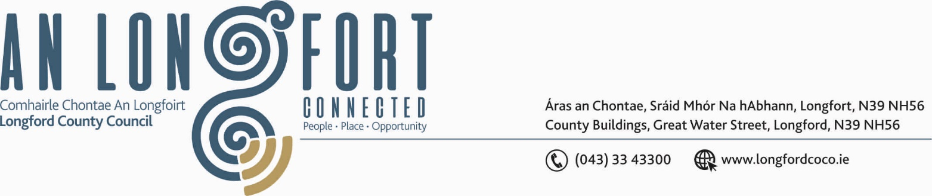

GRANARD MUNICIPAL DISTRICT

16th September 2020.

To: Each Member of Granard Municipal District.

Dear Member,

You are requested to attend Meeting of Granard Municipal District to be held in
Granard Community Library on Tuesday, 22nd September 2020 at 3.30 p.m.
to transact business, as set out on the Agenda hereunder.

Yours sincerely,


_______________
Anne Lee,
Meetings Administrator.

AGENDA

Prayer before meeting.

1. Confirmation of Minutes of the following Granard Municipal District Meetings held on the 28th July 2020-
(i) MD Committee Meeting.
(ii) July MD Meeting.
- copies enclosed

2. Matters arising from Minutes.

3. Declaration of Interest by Members.

4. Management Report incorporating Area Engineer’s Progress Report
- enclosed.

5. 2020 Special Projects Fund and Members Discretionary Fund.

6. Consideration of application received under the 2020 Community Grant Support Scheme - enclosed.

7. Granard Public Art Features.

8. Notices of Motions, submitted by Councillors, as listed hereunder –

Councillor P.J. Reilly.

“That the road leading up to the four industrial units at the rear of the unfinished shopping centre owned by the Council is made a public road and public lights be installed as this is a very dark area in the winter months.”

“That Longford County Council puts plans in place for CCTV cameras in Granard town to help prevent crime from occurring.”

Councillor Colin Dalton.

“I call on Longford County Council to consider providing funding for two outdoor benches for the sensory garden in Ballinalee.”

Councillor Turlough McGovern.

“That the paths in Derrycasson Woods be re -surfaced with crusher dust and made more passable for people using pushchairs, wheelchair users and children on bikes as currently it is impossible for them to use the paths safely. Also, improved signage is required as we have seen an influx of people using these facilities during the COVID pandemic.”

“That Longford County Council purchases Houricans Hotel (Main Street Granard) for the purpose of a car park, to facilitate passing trade to park
on the Main Street.”

9. Correspondence – enclosed.
- Correspondence received from Féileacáin (Stillbirth and Neonatal Death Association of Ireland) regarding “Wave of Light” Campaign
on the 15th October 2020.
- Correspondence received from Department of Rural and Community Development regarding Local Improvement Schemes.



